User Manual
How to change policy



Changing Security Policy in Outlook Add-in

Choose a security policy for each file to match the file’s security level. Change policies by clicking the dropdown menu, or keep the Default policy assigned by the system admin.
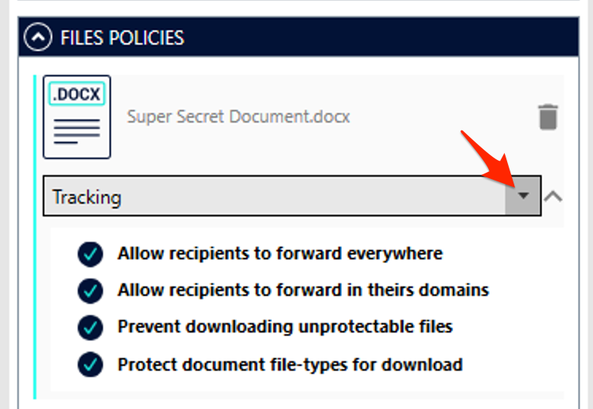

That’s it! You can continue composing your email and send it. Your attachments are secure.

Changing Security Policy for existing file

Right-click on the file that you already shared and choose “Security settings” from the menu.

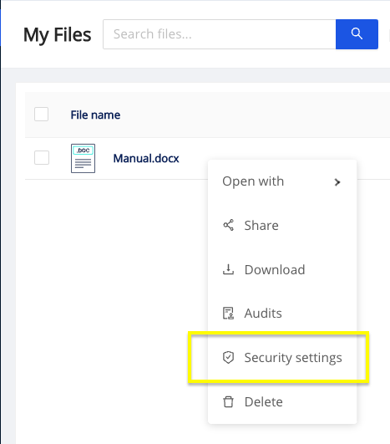

From the drop-down menu choose “Domain Forwarding” policy and press Apply button.

